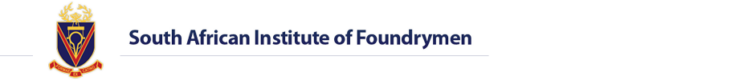
DTI
South African National Exhibitor Pavilion
at

GIFA 2015

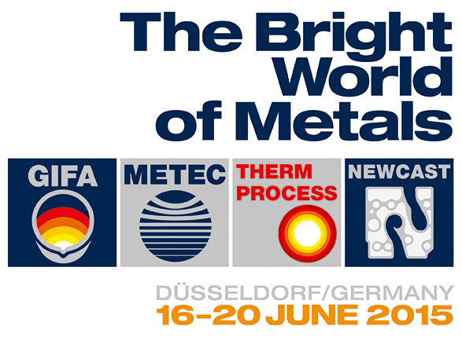
Business Breakfast Invitation  Dear „Contact Person“,  Messe Düsseldorf, in conjunction with The South African Institute of Foundrymen and The Southern African–German Chamber of Commerce and Industry, invites you to join the breakfast presentation in preparation for  GIFA, METEC, THERMPROCESS and NEWCAST (GMTN) 2015 exhibition  in Düsseldorf, Germany in June 2015.  Presentation Topics:  South African Foundry Industry Status Quo and Export Development Strategies  Registration for the South African National Exhibitor Pavilion at GIFA 2015:  - Complete guidance for “first time” exhibitors  - B2B matchmaking during your trade fair attendance  - Entering the international export market  - Schengen visa assistance  - Visitor entrance tickets  GMTN, Düsseldorf 2015:  GMTN is undoubtedly the most important meeting point for the professional metal industry worldwide, presenting you with informative and comprehensive knowledge on increasingly important topics relevant to the international metal industry.  For further information or support, please contact:  Innocentia Ndimande  South African- German Chamber of Commerce and Industry NPC | 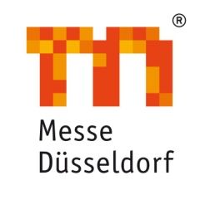
  Where: | Emperors Palace,( room name Fabia 1).
  Address: | 64 Jones Road Kempton Park, Johannesburg
  When: | Thursday, 05th February 2015
  Event Duration: | 09:00 – 11:00
  Entrance Cost: | Free of Charge
  RSVP attached: | (Ms) Innocentia Ndimande  Southern African–German Chamber of Commerce and Industry
  Email: | indimande@germanchamber.co.za
  Tel: | +27 (0) 11 486 2775
   | Breakfast will be served
  Speakers: | Mr. Friedrich-Georg Kehrer, GMTN Messe Düsseldorf,
   | Mr. John Davies, SAIF – South Africa Institute of Foundrymen
   | Mr. Bruce Crawford, Castings SA
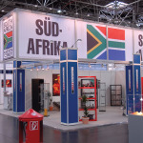
Registration for
The South African National Pavilion at
GIFA 2015:
Please click here
More info:
Please click here

 | 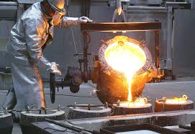
Companies and Products Scheduled to Exhibit at
GIFA 2015: click here
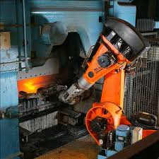

Representative of Messe Düsseldorf GmbH in South Africa
Po Box 87078, Houghton, 2041
T: +27(0)11 486 2775
F: +27(0)86 674 3816
indimande@germanchamber.co.za
www.germanchamber.co.za

Reg. No.: 1963/002981/09
Supported by: Federal Ministry for Economic Affairs and Energy on the basis of a decision by the German Bundestag

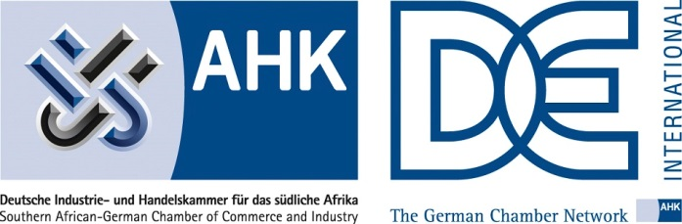



Subscription for newsletter Unsubscribe

